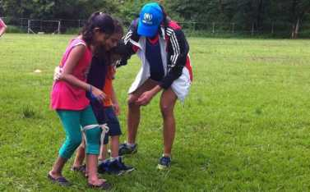

**UNHCR**

**The UN Refugee Agency**

HIGHLIGHTS

TRINIDAD AND TOBAGO

FACTSHEET

March 2017

326

Refugees, asylum-seekers, and other persons of concern in Trinidad and Tobago.

62%

Increase in the number of asylum­seekers who applied for asylum in 2016 compared to 2015.

20

Countries of origin, from Africa, Asia, the Middle East, South America and the Caribbean

Context Information

Main Countries of Origin

UNHCR FACTSHEET

* Trinidad and Tobago is one of the largest refugee-receiving countries in the Caribbean. In response to the growing number of asylum­seekers, the Government adopted a Refugee Policy in 2014 and UNHCR established an office in January 2016.
* UNHCR focuses on activities related to refugee status determination, capacity­building and advocacy. Protection activities are implemented in the areas of education, health, shelter, food security and durable solutions.
* UNHCR's Office in Trinidad and Tobago is operationally and financially managed by UNHCR's Regional Office in Washington.

Financial requirements

■ UNHCR's Office in Trinidad and Tobago is operationally and financially managed by UNHCR's Regional Office in Washington.

UNHCR presence

**Staff:**

1 international staff

**Offices:**

1 office located in Port of Spain

**6%**

**Cuba**

**36%**

**Other**

**10%**

**Pakistan**

**4%**

**Venezuela**

**11%**

**Colombia**

**6%**

Syrian Arab  
Republic  
20%

Bangladesh  
7%

HAITI

**HAITI**

DOM.

*Caribbean*

*Sea*

REP.

UNHCR

@ National Office

Map Sources: UNCS, UNHCR

The boundaries and names shown and the designations used on this map do not imply officii endorsement or acceptance by the United Nations Printing date 03 Mar 2017

CUBA

*NORTH ATLANTIC O* C

40km

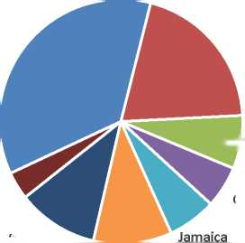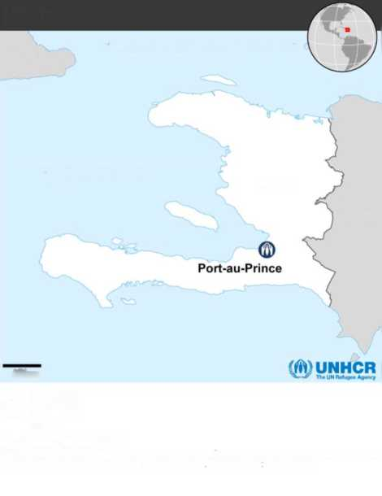

WORKING WITH PARTNERS

* UNHCR began collaborating with a local non-governmental organization, Living Water Community, in 1989. For over 25 years, Living Water Community identified and referred persons of concern to UNHCR, and ensured their access to protection. As UNHCR's implementing partner, Living Water Community provides psychosocial support and humanitarian assistance to asylum-seekers and refugees and facilitates the registration of asylum-seekers with UNHCR. Living Water Community also conducts participatory assessments with the refugee community.
* UNHCR works closely with the Immigration Division of the Ministry of National Security, which established a Refugee Office within the Ministry in 2016. UNHCR additionally works closely with sister UN agencies, regional bodies and other civil society organizations.

MAIN ACTIVITIES

Protection

The Refugee Policy, adopted in 2014, envisions the Government providing recognized refugees a permit of stay, work authorization and access to public assistance. While there are no current avenues for refugees to legally integrate into the country, the new refugee legislation is at an advanced drafting stage. As of April 2017, the Government will participate in the Quality Assurance Initiative project, which will contribute to the progressive transfer of responsibilities from UNHCR to the Government. As these developments unfold, UNHCR continues to conduct its refugee protection activities in the country, including refugee status determination under its Mandate; the provision of technical support and capacity building to the Government; and participation in public awareness events.

Education

Education is free in primary and secondary schools. However, barriers to education exist for many refugee children, including the lack of English language skills and a lack of spaces in schools. As a result, UNHCR:

* Facilitates the enrolment of refugee and asylum-seeker children in schools through Living Water Community;
* Cooperates with Living Water Community and the Ministry of Education to develop a protocol for UNHCR's persons of concern to ensure that children of concern have access to education, and that registration requirements including immunization cards, identification documents and previous school records would not present barriers.

Health, Shelter and Food Security

UNHCR ensures, through Living Water Community, that refugees are able to access services at public health facilities and through a network of private doctors who provide pro bono services to refugees. When necessary, persons of concern also receive financial assistance for medical costs or regular support for chronic conditions. Additionally, through Living Water Community, UNHCR assists persons of concern with specific needs with financial assistance to cover accommodation costs. Each month vulnerable persons of concern receive food products through Living Water Community's Food Bank, which UNHCR partially funds. Families are selected to receive this assistance based on particular vulnerabilities. Additionally, Living Water Community hosts a cash-for-work program to receive assistance each month.

Durable Solutions

* Currently, refugees are not able to obtain work permits and exercise the right to work, but efforts are underway to issue Minister's permits. As UNHCR advocates, and provides technical guidance, for the adoption of legislation and procedures to promote local integration, some refugees recognized under Mandate are submitted for resettlement. 25 refugees were resettled from Trinidad and Tobago to a third country in 2016.
* The Government of Trinidad and Tobago, in partnership with UNHCR, facilitates the achievement of durable solutions for refugees in the region through the Regional Refugee Transfer Mechanism. Within the mechanism, refugees are permitted to enter and stay in the country during the final stages of their resettlement processing, before their departure for resettlement to a third country. Since its inception, 13 refugees have been successfully resettled through this mechanism.

UNHCR is grateful for the generous contributions of donors who have given un-earmarked and broadly earmarked contributions to UNHCR this year as well as the following donors who have directly contributed to the operation: Sweden (76 M) | Netherlands (52 M) | Norway (41 M) | Denmark (23M) | Australia (19 M) | Switzerland (15M) | Germany (12M)

Contacts:

Ruben Barbado, Protection Officer, [BARBADO@unhcr.org](mailto:BARBADO@unhcr.org) Tel: +1 868 623 7056 ext. 266

Catia Lopes, External Relations Officer, [lopes@unhcr.org,](mailto:lopes@unhcr.org) +41 (0)2 2739 7204, [www.unhcr.org](http://www.unhcr.org/)